Below is the board for *Hell or High Water*.

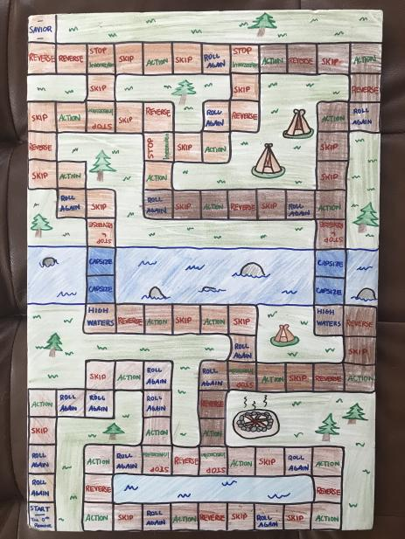

Below are examples of game pieces that players will use. They are replicas of colonial men and women, so players experience the game from a settler’s perspective, all the way down to their own shoes.

